specifications

Doc Version 0.1

Customer: | Reichmann & Sohn GmbH
Project: | New proALPHA
proALPHA version: | 9.2.1.
proALPHA installation(s): | EN
GUI language: | German
Author: | Bernhard Lauer
Created on: | Jun 21, 2023
Last Change On: | Jun 21, 2023
Contact person customer: | Werner Krause

This document describes an adaptation or extension of the standard software proALPHA and has been checked by the customer. The technical design in Chapters 2 - 4 is hereby released for technical specification and costing subject to the conditions set out in the section "Final Provisions":

................................................................................................................................................................................................................................................................
Date and signature customer

contents
1. [UPDATE THE TABLE] 3
1.1 [UPDATE THE TABLE] 3
1.2 [UPDATE THE TABLE] 3
1.3 [UPDATE THE TABLE] 3
1.4 [UPDATE THE TABLE] 3
2. [UPDATE THE TABLE] 4
2.1 [UPDATE THE TABLE] 4
2.2 [UPDATE THE TABLE] 4
2.2.1 [UPDATE THE TABLE] 4
2.3 [UPDATE THE TABLE] 5
3. [UPDATE THE TABLE] 6
3.1 [UPDATE THE TABLE] 6
4. [UPDATE THE TABLE] 7
4.1 [UPDATE THE TABLE] 7
4.2 [UPDATE THE TABLE] 7
4.3 [UPDATE THE TABLE] 7
5. [UPDATE THE TABLE] 8
5.1 [UPDATE THE TABLE] 8
5.1.1 [UPDATE THE TABLE] 8
5.1.2 [UPDATE THE TABLE] 8
5.1.3 [UPDATE THE TABLE] 8
6. [UPDATE THE TABLE] 9
7. [UPDATE THE TABLE] 10
7.1 [UPDATE THE TABLE] 10
7.2 [UPDATE THE TABLE] 10
8. [UPDATE THE TABLE] 11

Requirements

References
The request has been accepted as a change request.

Combination and objectives
Reichmann & Sohn would like to expand the "Editing Parts" browser by means of the Manufacturer field.
If the manufacturer is restricted, only parts assigned to the respective manufacturer are filtered.

requirement specification
In order to expand the filter options in the part master files, the following information is to be added to the "Editing Parts" prefilter:
S_ArtHerst.
ManufacturerS_ArtHerst.PO Number
If the "Manufacturer" filter is set, the part numbers assigned to the manufacturer are limited. It is irrelevant whether the manufacturer is classified as the main producer or not.
If the PO Number Manufacturer filter is set, the part numbers defined by the manufacturer are limited to the part numbers.
If both filter criteria have been set, only the part number with the manufacturer's PO number is selected.
Further filter criteria are as usual in the standard version.

Requirements glossary (explanation of terms)

term | explanation
Table 1: request glossary

Technical design

Solution Summary

Solution description

Selection fields in the "Editing Parts" filter

Business logic & GUI
Editing Parts filter is opened either with the "Ctrl+g" shortcut or when the "Editing Parts" program is opened (s_part16.w program)
A new filter manufacturer is placed on the mask (S_ArtHerst.Manufacturer). The filter is a From - To
FilterA new Filter Manufacturer PO Number is placed on the mask (S_ArtHerst PO Number). The filter is a From - To filter
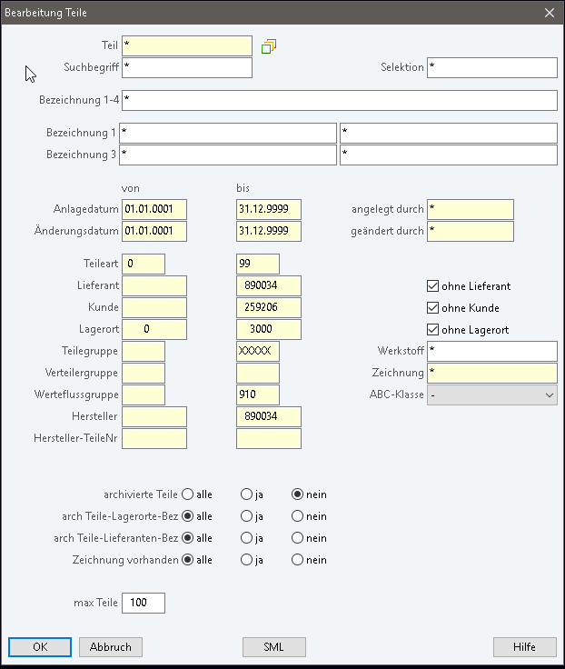

If the "Manufacturer" filter is set, the part numbers assigned to the manufacturer are limited. It is irrelevant whether the manufacturer is classified as the main producer or not.
If the PO Number Manufacturer filter is set, the part numbers defined by the manufacturer are limited to the part numbers.
If both filter criteria have been set, only the part number with the manufacturer's PO number is selected.
Further filter criteria have the same effect as in the standard version

data model
Not relevant

Output
Not relevant

differentiation
The customization refers to the tables, fields and programs mentioned above.
This specification does not automatically make functional expansions in adjacent modules of the proALPHA environment, such as DMS, Analyzers, reports and forms. The proALPHA help is not automatically expanded either.
Changes to adjacent modules / programs have to be described and defined in the specifications.

Test cases
The specified test cases map the adaptation described here and are the basis for the acceptance of the software.

Editing Parts browser
Pct. | description | Expected result | test data
 | Opening the editing parts browser, filtering them to manufacturer "830130" | All part master files with assigned manufacturer 830130 have to be displayed. Currently at least part master files 1000167 (version Test1 of 21.06.23)
 | Test result (including screenshots)
 | Filtering the browser editing parts to manufacturer PO number "123456" | Part master files 1000167 and 1000020 must be displayed (same manufacturer part number, different manufacturers)
 | Test result (including screenshots)
 | Opening the browser editing parts to manufacturer 830130 and manufacturer order number "123456" | Part master files 1000167 are displayed
 | Test result (including screenshots)

Prerequisites

Technical requirements
The use of proALPHA functionalities outside the Concurrent User Model (connection of external systems, background processing) requires the licensing of so-called software services.
"Using proALPHA functionalities" means any use or access to the proALPHA infrastructure, e.g.
- Writing in data structures of proALPHA
- Calling proALPHA classes and other business logic
- Calling proALPHA services
The following software services are therefore required for the implementation described in the specifications:
- <List services here, otherwise delete section>
- ...

Organizational prerequisites

Notes about commissioning

Technical design

<template for section>

surface

business logic

data model

Final provisions
This specification forms the basis for customer-specific expansions of the standard software proALPHA®.
The customer-specific expansions only include the category defined in this specification. Functionality beyond this scope is not provided.
Unless expressly agreed otherwise, the customer-specific expansions are only created in German: Programs, program parts or data are not translated into other languages. This also applies to the languages supported by proALPHA® in the standard version.
The customer-specific expansions are carefully tested before they are delivered. However, for technical reasons, it is not possible to perform the test under the same conditions and with the same data as the customer. It is therefore recommended to carefully check the functions after they have been delivered in the real system environment.
The customer is aware that variances in display details or handling may be required for transferring the functions defined in this specification to new versions of proALPHA®. This specification also remains valid in this case, provided that there is a maintenance agreement for the customer-specific expansions defined in this specification and that no changes to the functionality have to be agreed.
This specification documents the customer-specific expansions. No other documentation than the service specification contained in this specification is to be provided. Questions about customer-specific expansions are accepted and forwarded by the hotline.
By signing on page 1 you confirm:
that the specification is accepted in this version and becomes part of the contract,
that this specification defines the scope of functions of the software to be created and that there are no side agreements regarding the functionality.

appendix

table of figures
No entries for an image directory could be found.

table index
TOC \h \z \c "Tabelle" No entries for an image directory could be found.

Change history
Doc. -  version | Date | specialist | initiator | Chapter | description
0.1 |  | Bernhard Lauer | Werner Krause | All | Initial new entry

